|  |  |
| --- | --- |
| Roll. No.: A022 | Name: Kartik Padave |
| Sem/Year: VII/4 | Batch: 1 |
| Date of Experiment: 13/08/2022 | Date of Submission: 27/08/2022 |
| Grade -- |  |

**Create wireless network in ns2**

# **Theory**

Simple Wireless Program in NS2 is the best way to learn about how to code in NS2. NS-2 is one of the best simulation tools. It is used by majority of scholars today due to its highlighted features like support for OOPs concept, C++ programming fundamentals, real time emulation support etc. NS2 is used to simulate both wired and wireless networks; here we have focused on wireless network simulation in NS-2 due to its wide applicability. Regarding wired simulation in NS-2, refer our other articles available in this site.

Here, we have taken a simple wireless program in NS-2 to explain the students about how to work with wireless networks in NS-2. For further guidance and tutoring service on NS-2, approach us anytime, we are there for you at 24/7.

# **Code**

*#Create a simulator object*

set ns [new Simulator]

*#Define different colors for data flows*

$ns color 1 Blue

$ns color 2 Red

*#Open the nam trace file*

set nf [open out.nam w]

$ns namtrace-all $nf

*#Define a 'finish' procedure*

proc finish {} {

global ns nf

$ns flush-trace

#Close the trace file

close $nf

#Execute nam on the trace file

exec nam out.nam &

exit 0

}

*#Create four nodes*

set n0 [$ns node]

set n1 [$ns node]

set n2 [$ns node]

set n3 [$ns node]

*#Create links between the nodes*

$ns duplex-link $n0 $n2 1Mb 10ms DropTail

$ns duplex-link $n1 $n2 1Mb 10ms DropTail

$ns duplex-link $n3 $n2 1Mb 10ms DropTail

$ns duplex-link-op $n0 $n2 orient right-down

$ns duplex-link-op $n1 $n2 orient right-up

$ns duplex-link-op $n2 $n3 orient right

*#Monitor the queue for the link between node 2 and node 3*

*#set aa [$ns duplex-link-op $n2 $n3 queuePos 0.5]*

*#puts $aa*

$ns duplex-link-op $n2 $n3 queuePos 0.5

$ns queue-limit $n2 $n3 10

*#Create a UDP agent and attach it to node n0*

set udp0 [new Agent/UDP]

$udp0 set class_ 1

$ns attach-agent $n0 $udp0

*# Create a CBR traffic source and attach it to udp0*

set cbr0 [new Application/Traffic/CBR]

$cbr0 set packetSize_ 500

$cbr0 set interval_ 0.005

$cbr0 attach-agent $udp0

*#Create a UDP agent and attach it to node n1*

set udp1 [new Agent/UDP]

$udp1 set class_ 2

$ns attach-agent $n1 $udp1

*# Create a CBR traffic source and attach it to udp1*

set cbr1 [new Application/Traffic/CBR]

$cbr1 set packetSize_ 500

$cbr1 set interval_ 0.005

$cbr1 attach-agent $udp1

*#Create a Null agent (a traffic sink) and attach it to node n3*

set null0 [new Agent/Null]

$ns attach-agent $n3 $null0

*#Connect the traffic sources with the traffic sink*

$ns connect $udp0 $null0

$ns connect $udp1 $null0

*#Schedule events for the CBR agents*

$ns at 0.5 "$cbr0 start"

$ns at 1.0 "$cbr1 start"

$ns at 4.0 "$cbr1 stop"

$ns at 4.5 "$cbr0 stop"

*#Call the finish procedure after 5 seconds of simulation time*

$ns at 5.0 "finish"

*#Run the simulation*

$ns run

# **Output**

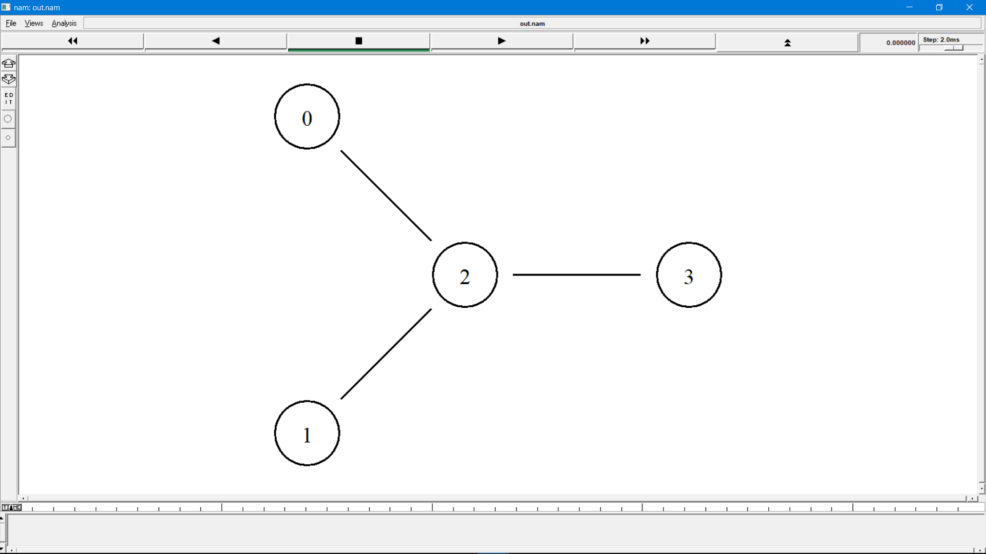

**Conclusion**

Hence, we were able to perform the experiment.